Media Relations and Social Media (Kelly Tabor)
Help update templates for press releases, letterhead, newsletters, etc.
Contribute to concepting themes for the Lottery calendar.
Assist with planning proceeds and Lottery product promotional events & sponsorships.
Help with posts for WooBox Facebook drawings.
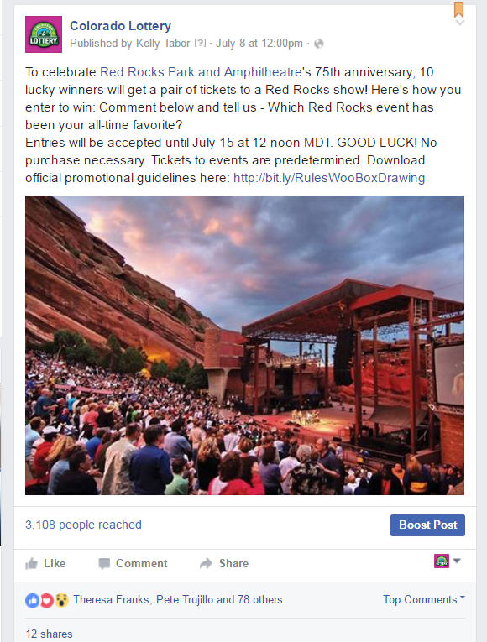

Create images for social media posting.
